1. Steps how to create branches in azure git repo.

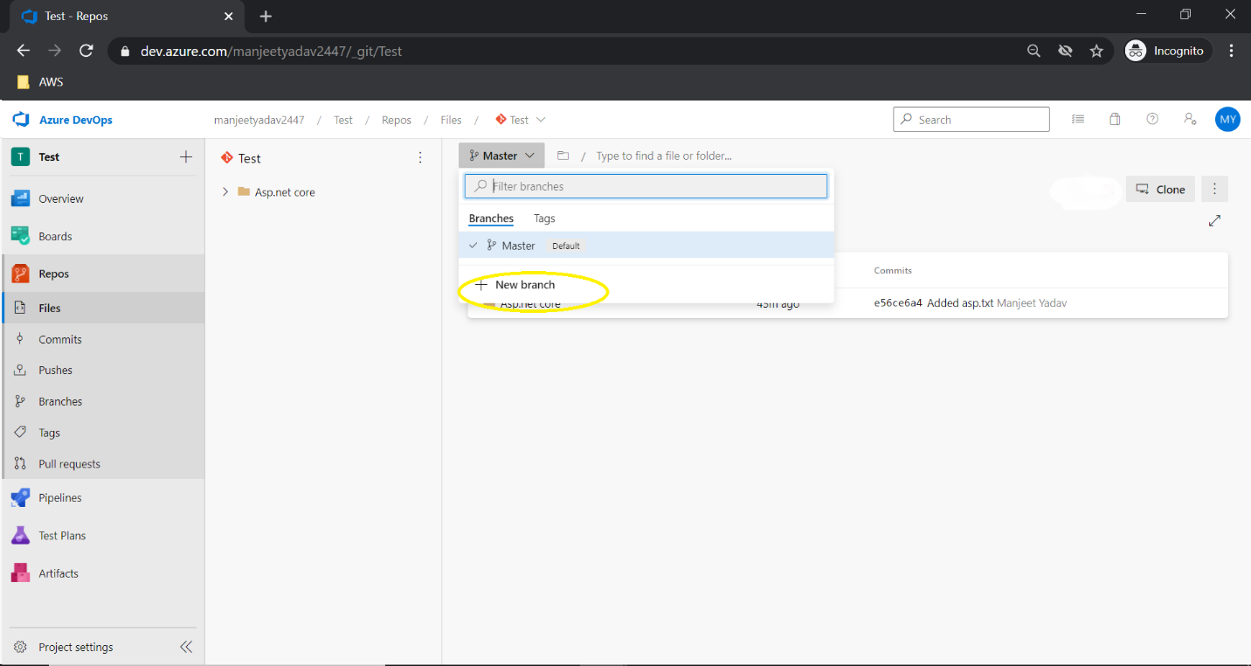

1. Please see the important note that I highlighted in red color(how to clone and push your code to azure git) –

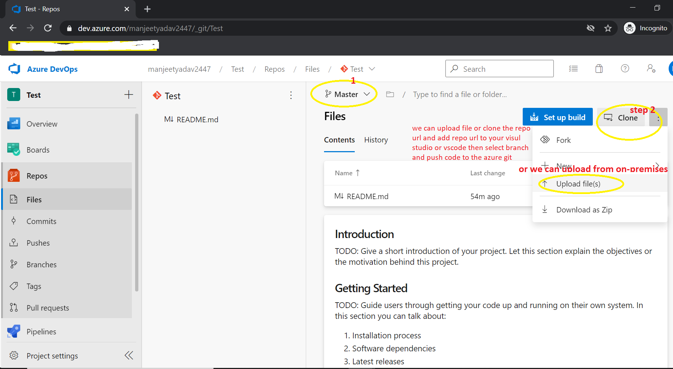

1. Steps for how to create build pipeline for dotnet Web App and Web Api project.

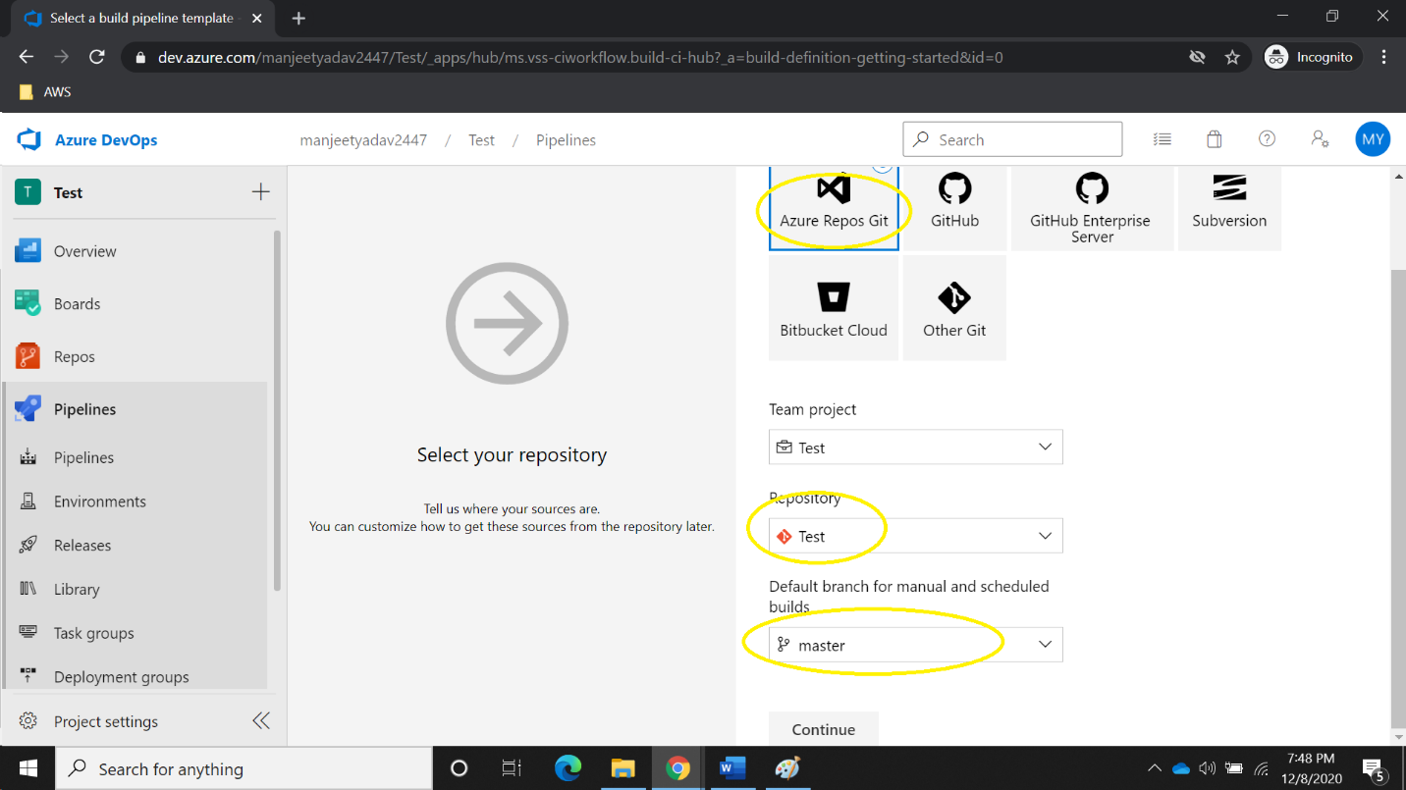

1. Select build Agent so Select MS hosted agent ubuntu-20.04 because docker dose not support windows agent.

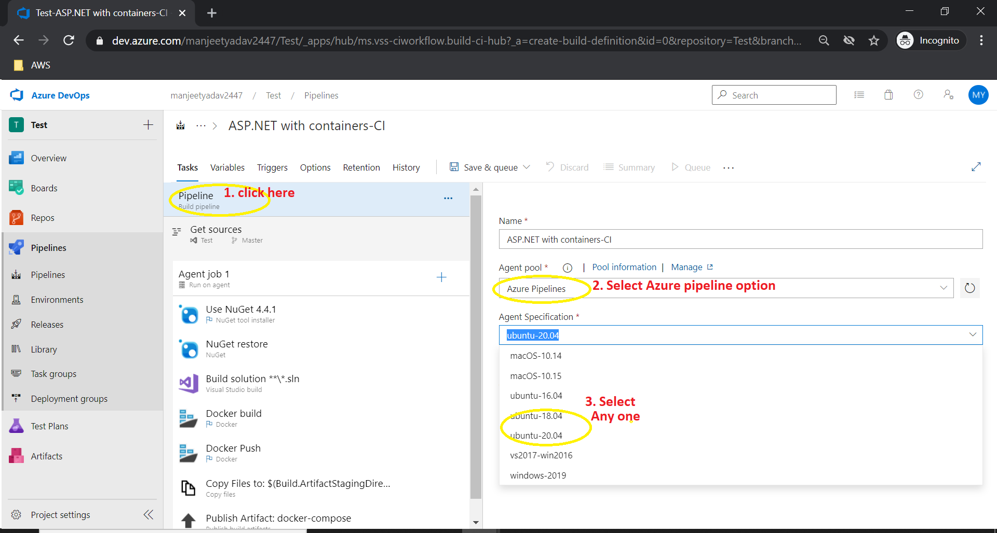

1. Steps for add task in the build pipeline.

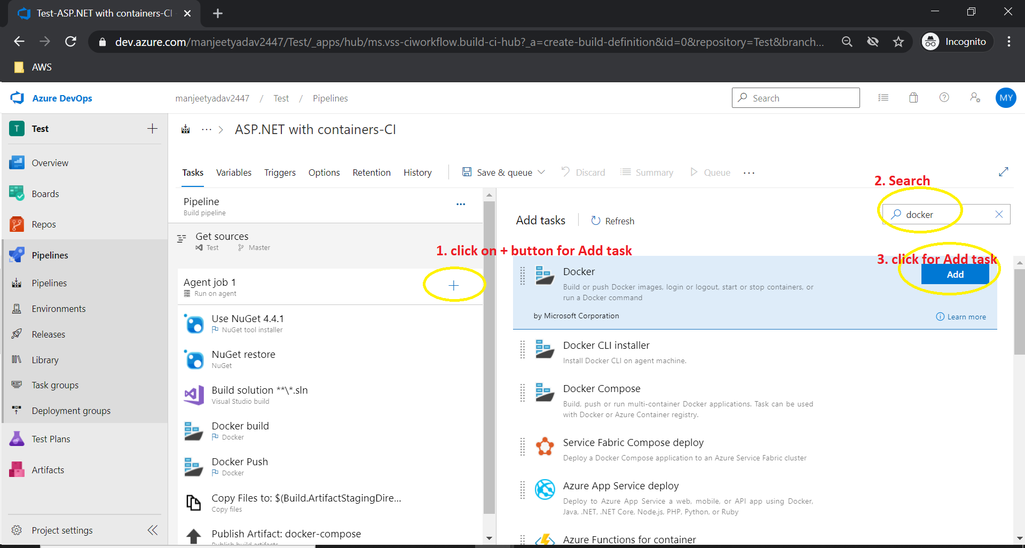

1. Steps for how to set build pipeline auto trigger when developer merge code into master branch.

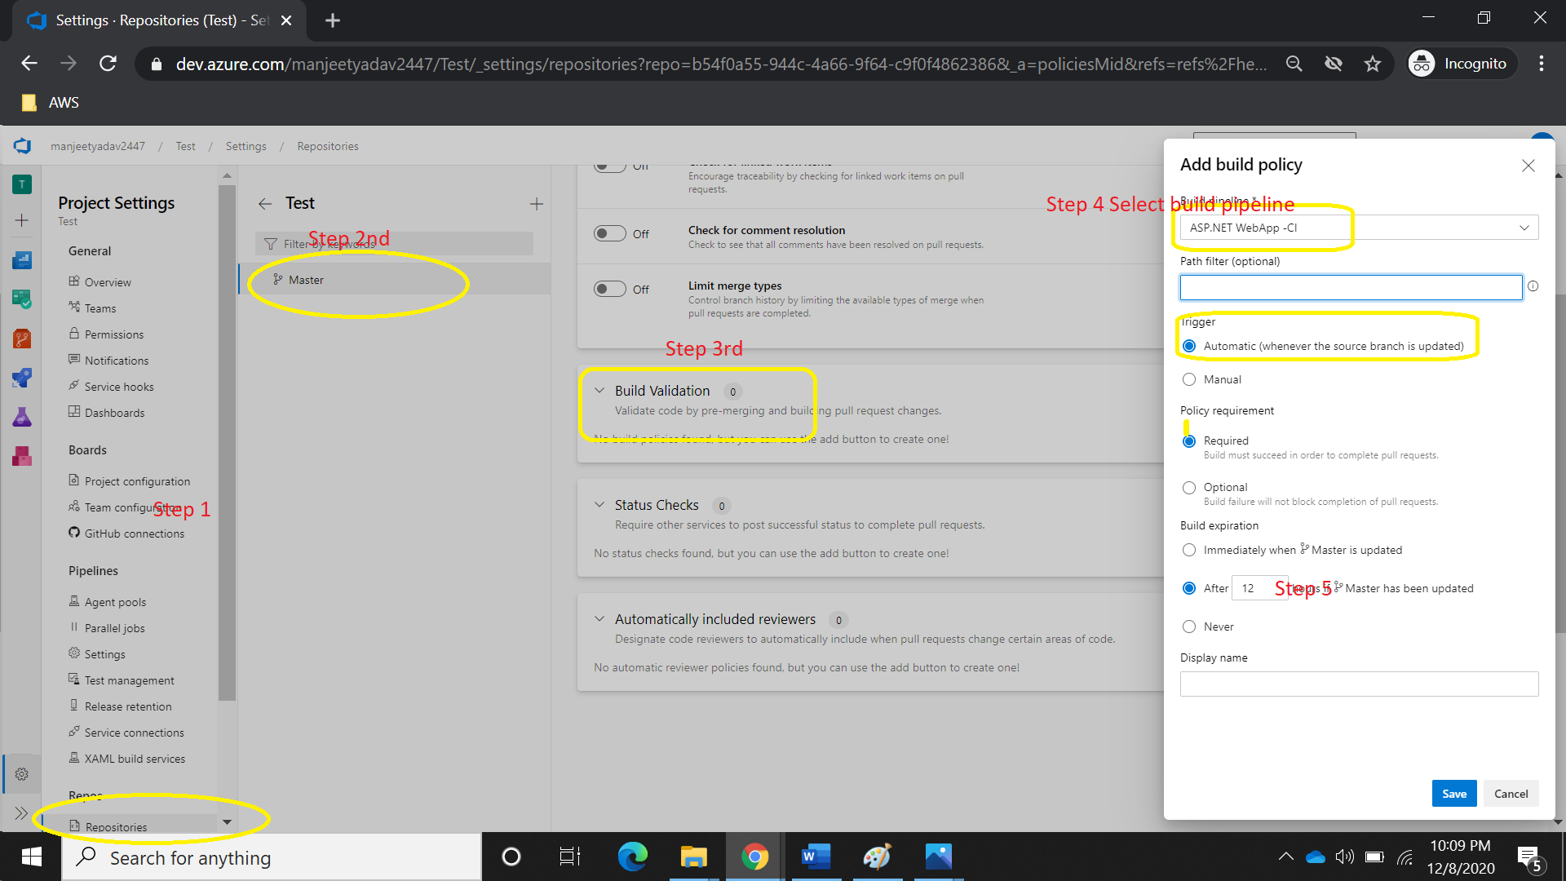

1. Second way once we create PR to merge code from Feature branch (developer branch) to master branch so we can set auto trigger from pipeline also. Pleas find the below screenshot.

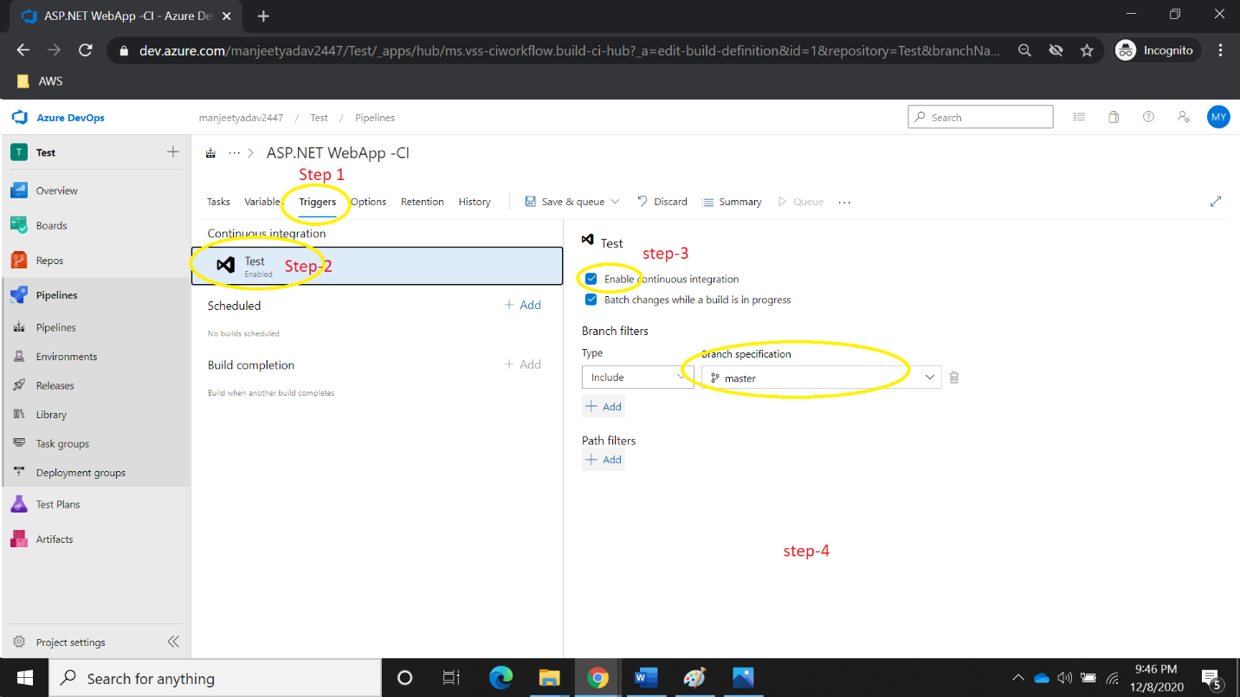

1. Below Screenshot represent how to install and select nuget pkg version.

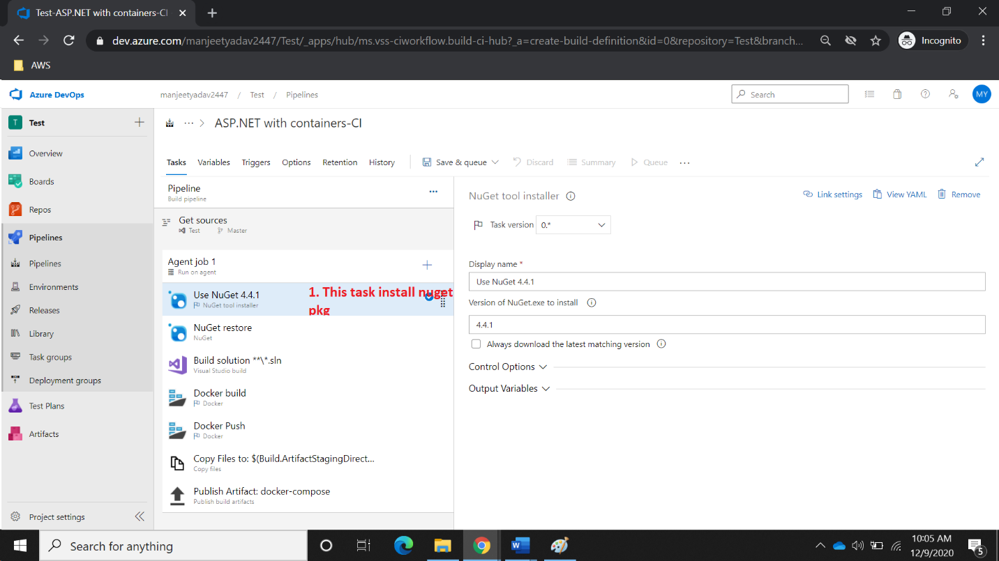

1. Restore nuget package and its dependencies.

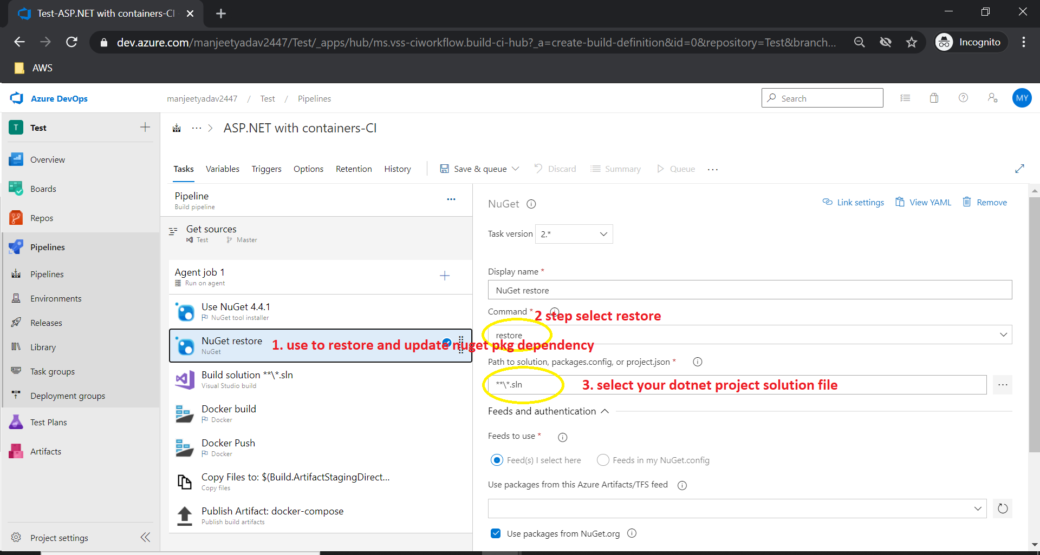

1. Steps, how to create build of your dotnet project solution file.

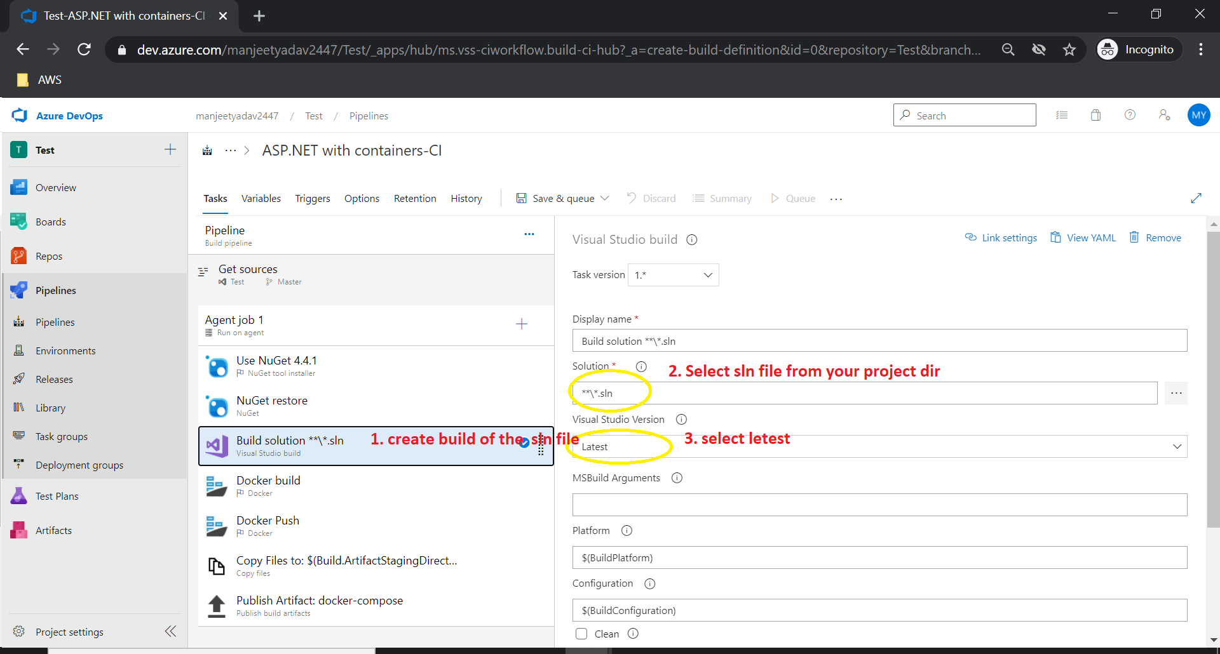

1. Steps, how to create docker image into the azure container registry (ACR)

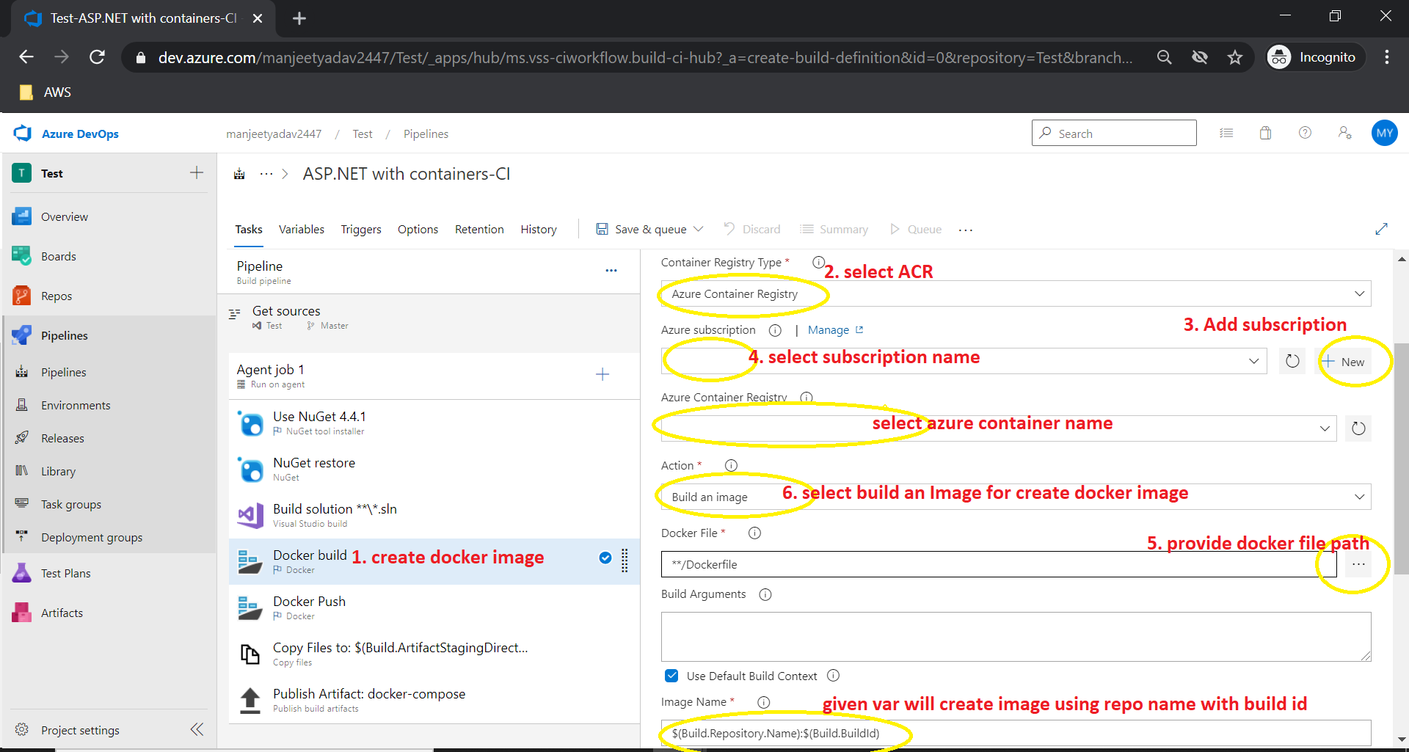

1. Push your docker build image into Azure container registry.

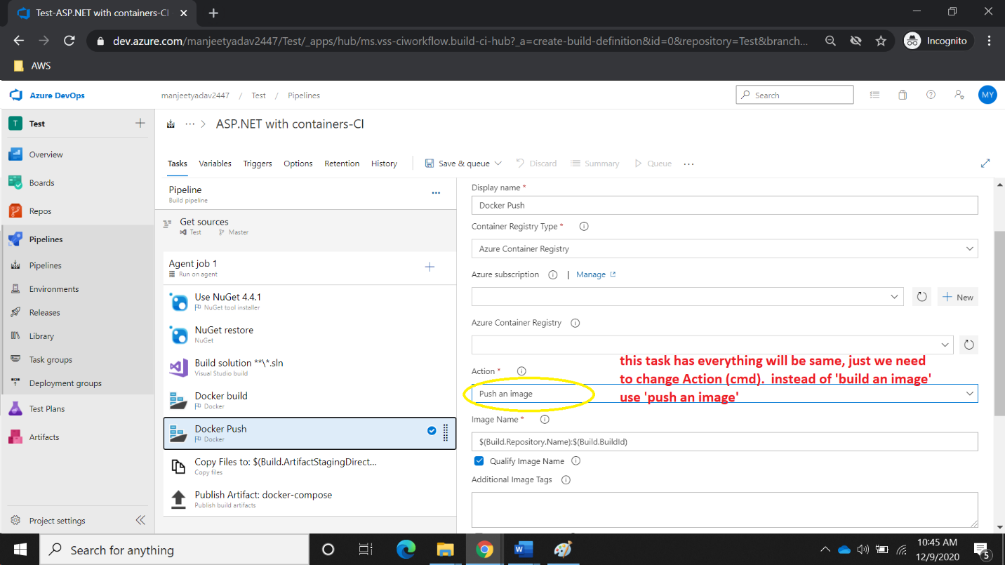

1. Steps Copy Yaml Aks deployment file in the devops artifact folder.

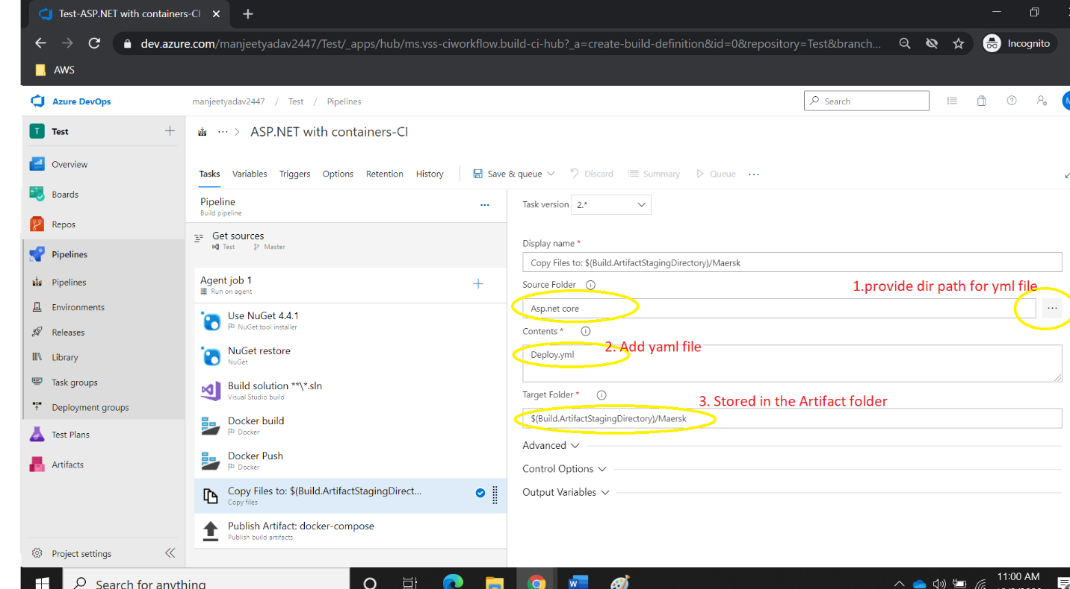

1. Store file in Artifact drop folder.

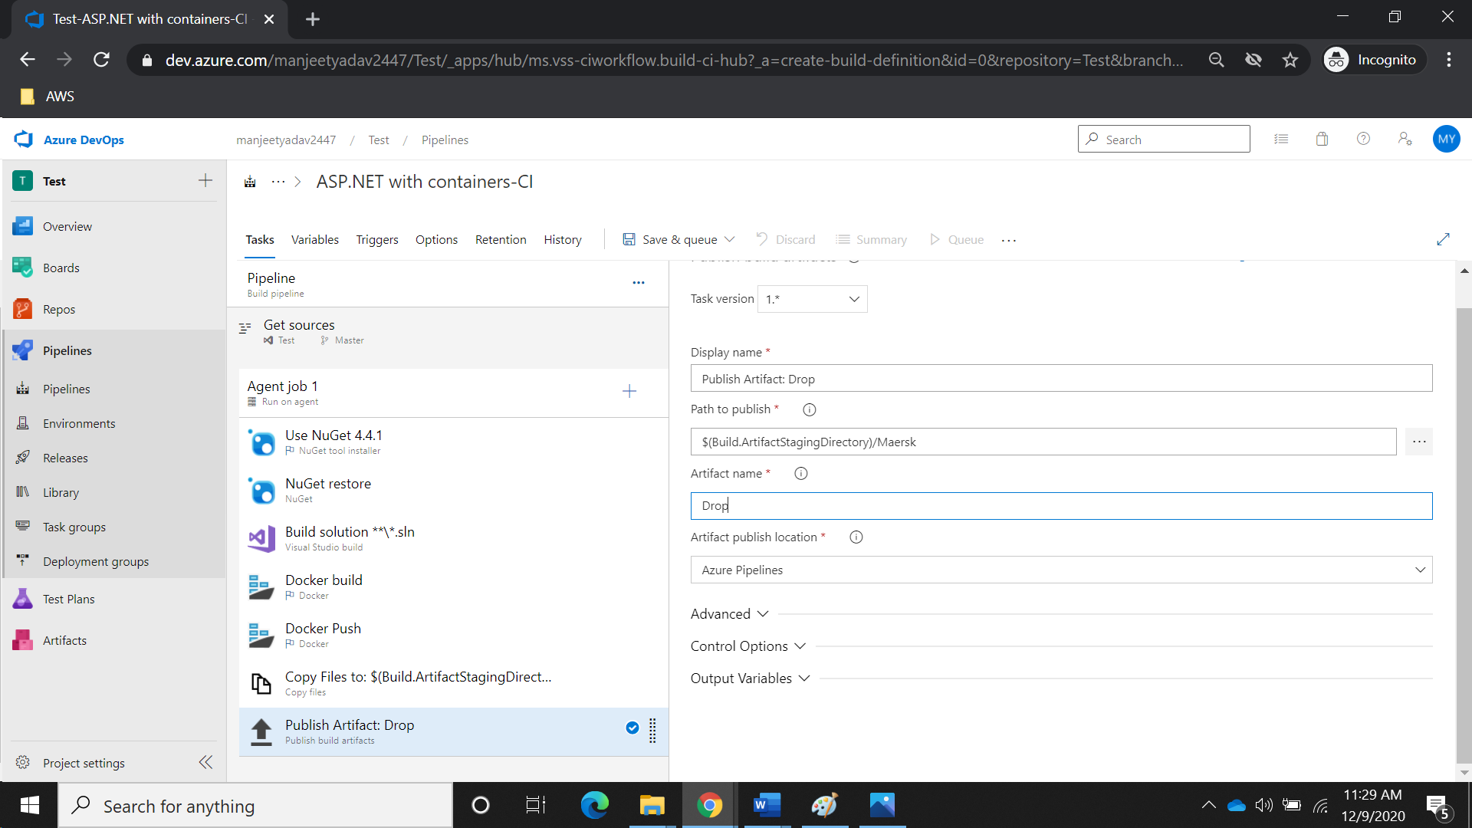

CREATE RELEASE (CD) PIPELINE FOR AKS DEPLOYMENT

1. Steps for Create release Pipeline.

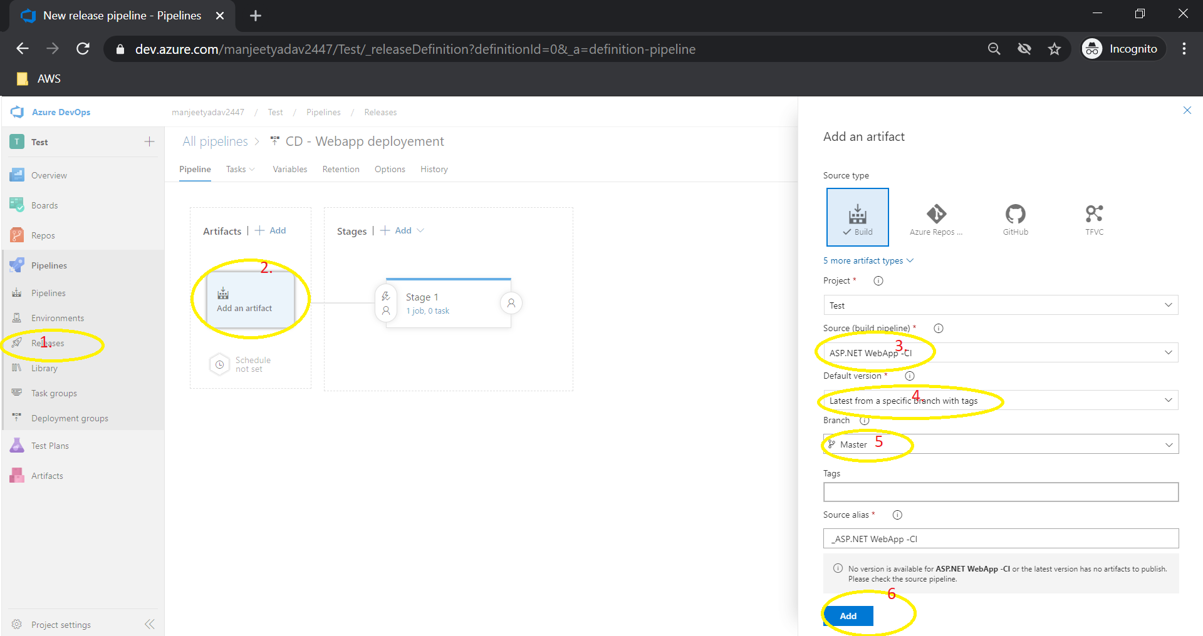

1. Set Staging for DEV, QA and PROD.

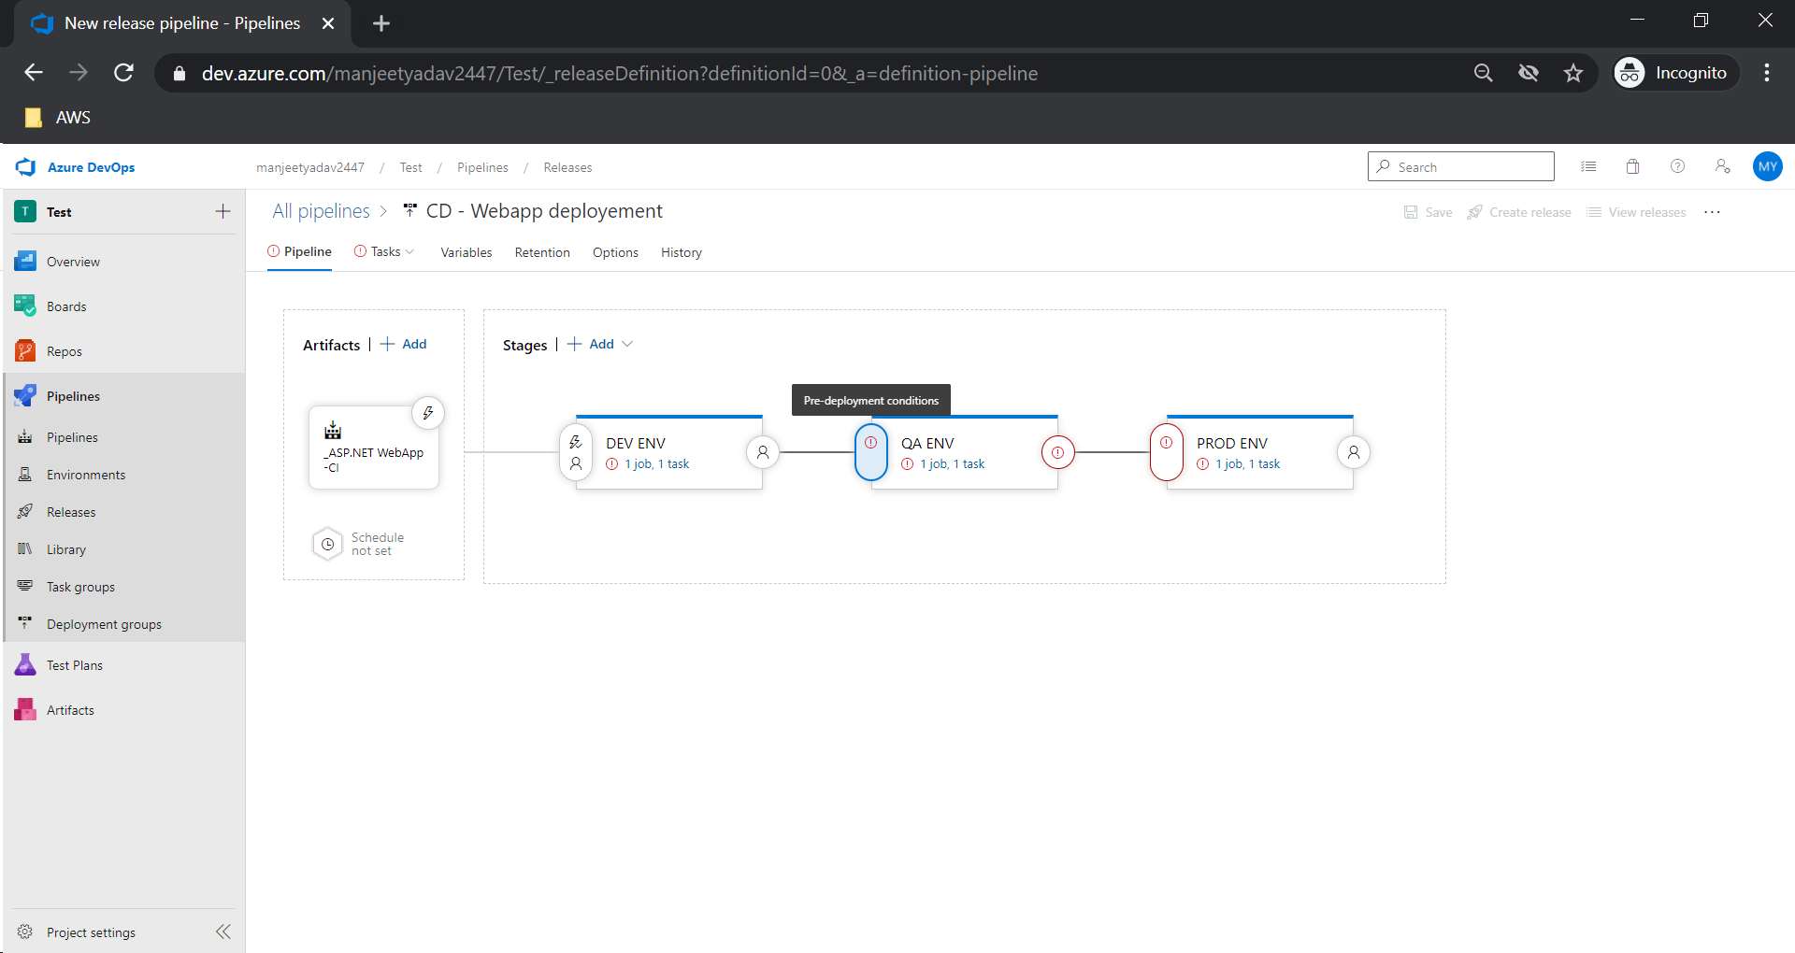

1. Add approver for higher environment like QA and PROD.

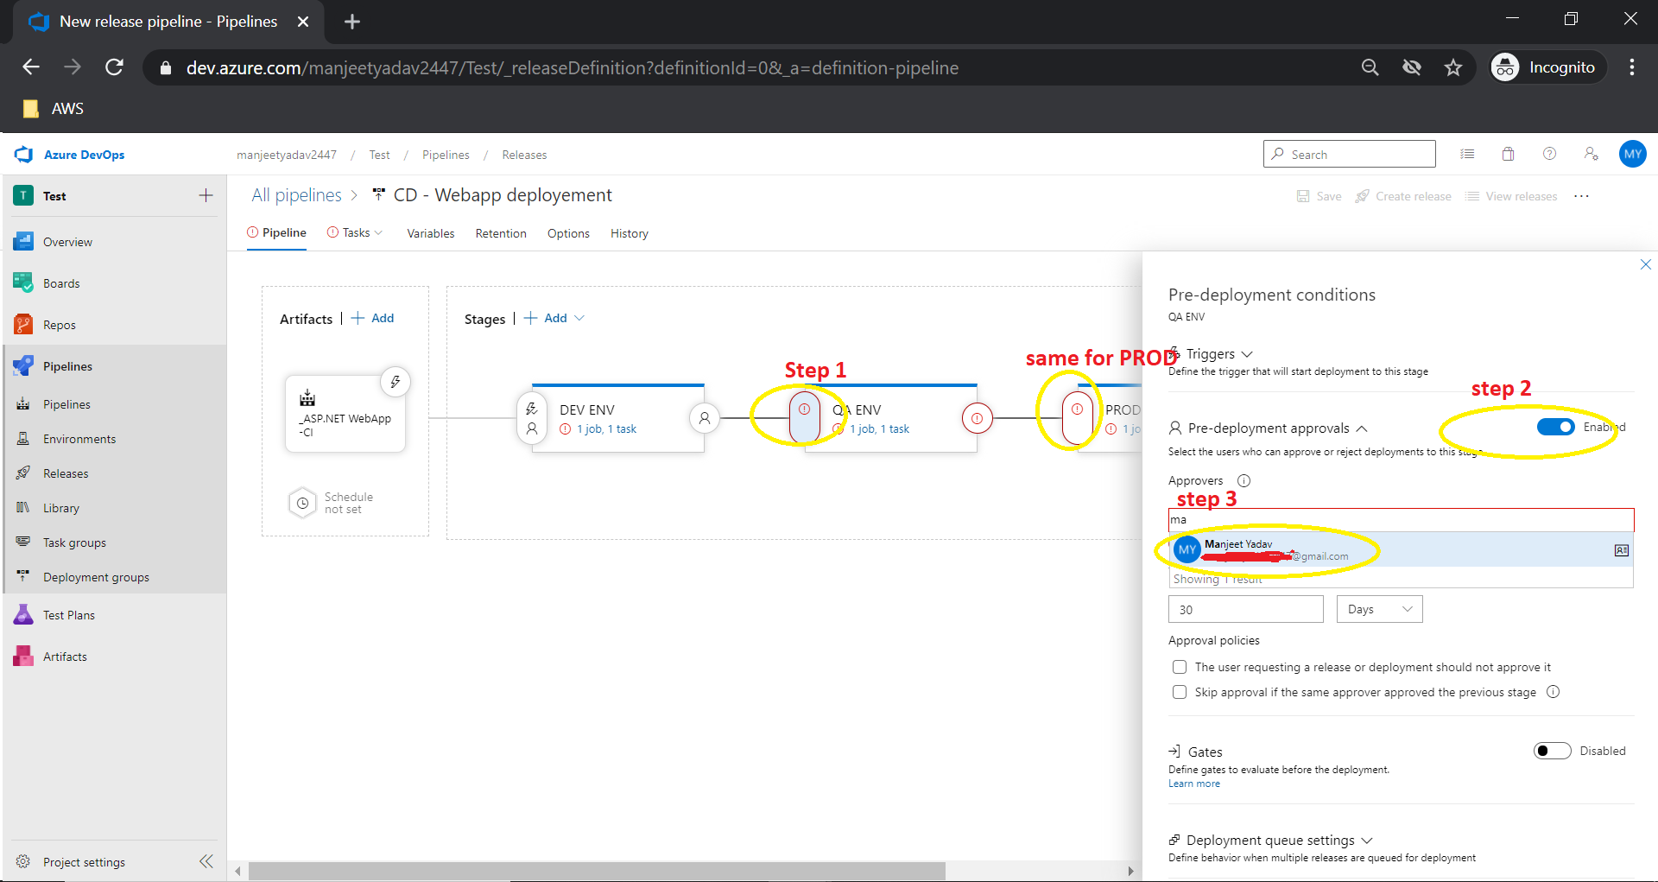

1. Steps for AKS deployment.

